Operation
This chapter provides personnel with instructions on executing opera‐ tion modes.

  - Safety instructions
DANGER!
Danger as a result of starting a machine that is not ready for operation!
Serious injury to operating and maintenance personnel and/or considerable property damage could result if the machine is insufficiently or incorrectly prepared.
There is a risk of injury if safety devices are inoperable or have been rendered inoperable.
– Ensure that the conditions for machine readiness have been met before switching on the machine. See the chapter entitled ‘Operation’, section ‘Pre‐ paring the machine for operation’
WARNING!
Ignoring safety instructions
Risk of injury if safety instructions are ignored. This could result in severe or fatal injury.
– Safety instructions must be complied with, see the
‘Safety’ chapter.

  - Safety equipment
    - Emergency stop switch
      - Overview
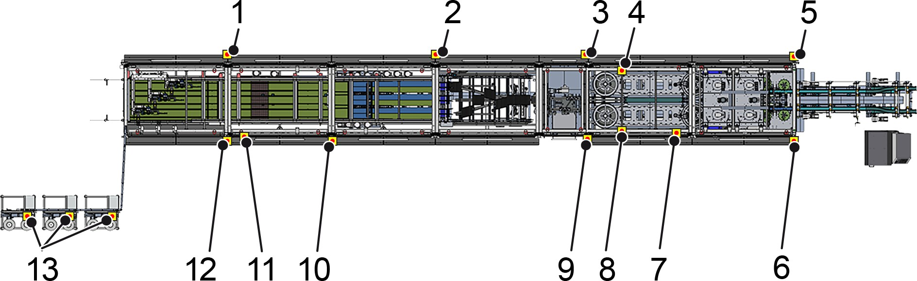

Figure 156: Machine
- Emergency stop switch at the infeed of the "Carrying handles" process module (rear)
- Emergency stop switch at the infeed of the "Turning" process module (rear)
- Emergency stop switch at the infeed of the "Ejecting" process module (rear)
- Emergency stop switch for the "Changing station" (rear)
- Emergency stop switch at the infeed of the "Separate" process module (rear)
- Emergency stop switch at the infeed of the "Separate" process module (operator side)
- Manual control unit on the front machine section
- Emergency stop switch for the "Changing station" (operator side)
- Emergency stop switch at the infeed of the "Ejecting" process module (operator side)
- Emergency stop switch at the infeed of the "Buffering" process module (operator side)
- Manual control unit on the rear machine section
- Emergency stop switch at the infeed of the "Carrying handles" process module (operator side)
- Emergency stop switch for the "Adhesive tape station"
Additional emergency stop switches are located on conveyor systems that are assigned to the machine.

      - Function and operation


Figure 157: Emergency stop switch
An emergency stop switch is fixed to the machine and, when actu‐ ated, the drives immediately switch off.
If a dangerous situation occurs, the personnel must immediately press an emergency stop switch to shut down the machine.

Pressing the emergency stop switch

NOTICE!
Emergency stop switch
Property damage resulting from improper use of the emergency stop switch. Emergency stop switches are safety devices which should only be used in an emer‐ gency situation.
This may result in damage to the machine or to items in the surrounding area.
– Do not use the emergency stop switch to switch off normally.

Personnel:  Operating personnel Prerequisite:
        - A hazardous situation has occurred.

- Press the emergency stop switch.
  - The machine drive stops.
The touchscreen displays the "Emergency stop switch actu‐ ated" fault message.
The corresponding lights on the signal lights are illuminated.
WARNING!
Residual energy when the machine is switched off
There is a risk of injury after switching off the machine from the inertia of moving parts and other residual energy.
This could result in severe or fatal injury.
When faults occur, components are not always able to return to their end positions and retain residual energy (potential energy). When rectifying faults, components may begin to move uncontrollably in order to reduce their residual energy.
- After pressing the emergency stop button, bear in mind the inertia of moving parts.
- Secure and de-energise the machine before carrying out any work on the machine.
- Attend to injured personnel at the installation site in accordance with first aid guidelines.
- Rectify the hazardous situation; see the chapter entitled

‘Faults’.

Switching the machine on again after an emergency stop
WARNING!
Improper unlocking of the emergency stop button
Danger when unlocking the emergency stop switch if the emergency situation has not been rectified.
This could result in severe or fatal injury.
- Determine why the emergency stop switch was actuated.
- Rectify emergency situation.
- Before unlocking and restarting the machine, ensure that there is no one in the hazardous machine area.
Personnel:  Operating personnel Prerequisite:
- There is no longer a dangerous situation.
- Eliminate the reason for the emergency stop switch being pressed.
- Ensure that no personnel are in the danger areas.
- Turn or pull the emergency stop switch to the left until it unlocks.
  - The machine is ready for start-up again.
- Check the machine. See below.
- Set the [Operation On/Off] key switch to [Off] and then back to

[On].
  - The status display lights up.
- Press the [Delete fault] button.
- Press the [Start] button.

Checking the machine
Personnel:  Operating personnel
Check the following components.
Product feed
- Remove any faulty or fallen products. Separate
- Remove faulty products and replace with correct products. Hold the products by the closure or at the upper edge only.
Alignment
- Remove faulty products and replace with correct products. Hold the products by the closure or at the upper edge only.
Gluing
- Check the hot-melt glue application heads.
- Clean all parts that are contaminated with hot-melt glue res‐ idue.
Distribution
- Remove faulty pack. Turning
- Remove faulty pack. Buffering
- Remove faulty pack. Carrying handles
- Remove faulty pack.
- Check flow, tension and cleanliness of adhesive tape.

    - Safety doors
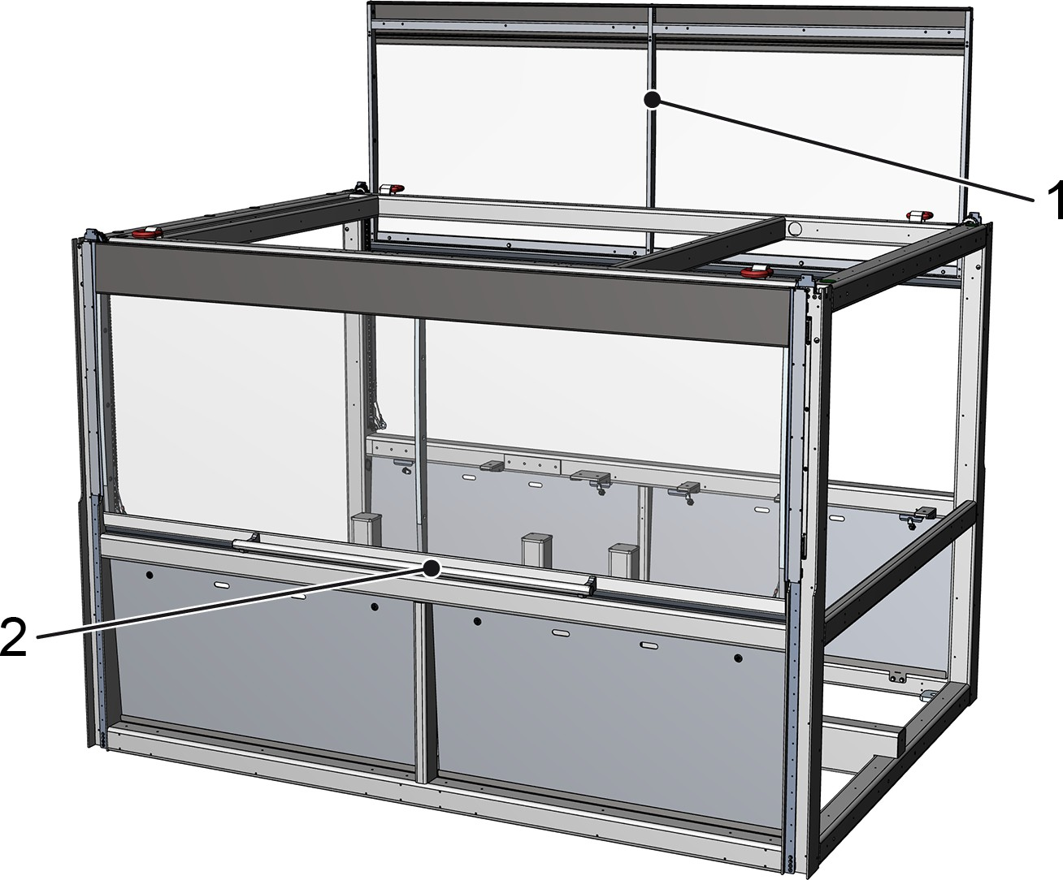

Figure 158: Safety doors
- Opened safety door
- Handle on the safety door
The safety doors prevent the operator or any other person from reaching into the machine while it is in operation. The safety doors prevent product parts from being ejected and serve as noise protec‐ tion.
When the machine is running, the safety doors are secured with an electromagnetic locking mechanism. This aids process safety. If the safety doors are opened by force, the machine stops immediately and goes into emergency stop mode.
Before opening the safety doors, the machine must be stopped and the locking mechanism must be deactivated.

Opening the safety door
Personnel:  Operating personnel Prerequisite:
- The machine is at a standstill and is not producing.
- The [Lock doors] button lights up.
- Press the [Lock doors] button.
  - The [Lock doors] button flashes.
- Push the safety door upwards using the handle.
  - The [Lock doors] button does not light up.

Closing the safety door
Personnel:  Operating personnel Prerequisite:
- The machine is ready for operation, see section ‘Preparing for operation’.
- Close all safety doors on the machine.
  - The [Lock doors] button flashes.
- Press the [Lock doors] button.
- Press the [Delete fault] button.
- Start the machine.

    - Safety door on container
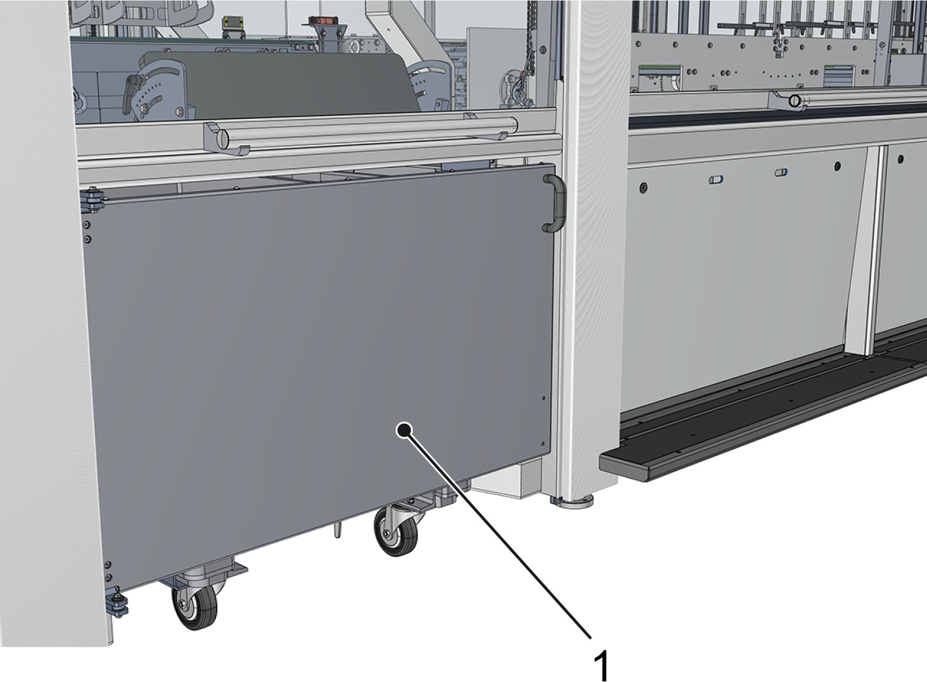

Figure 159: Safety door on container
1 Safety door on container
The safety door is located on the operator side in the "Ejecting" process module.
When the machine is running, the safety door is secured with an electromagnetic locking mechanism. This aids process safety.

Opening the safety door
Personnel:  Operating personnel Prerequisite:
- No faulty packs are located in the front section of the machine.
- The [Remove container safety door] button is flashing.
- Press the [Remove container safety door] button.
  - The ejection slot is closed.
- Open the safety door.
- Remove the full container.
- Insert the empty container.
- After closing the safety door, press the [Remove container safety door] button again.

    - Safety light curtain in the "Carrying handles" process module
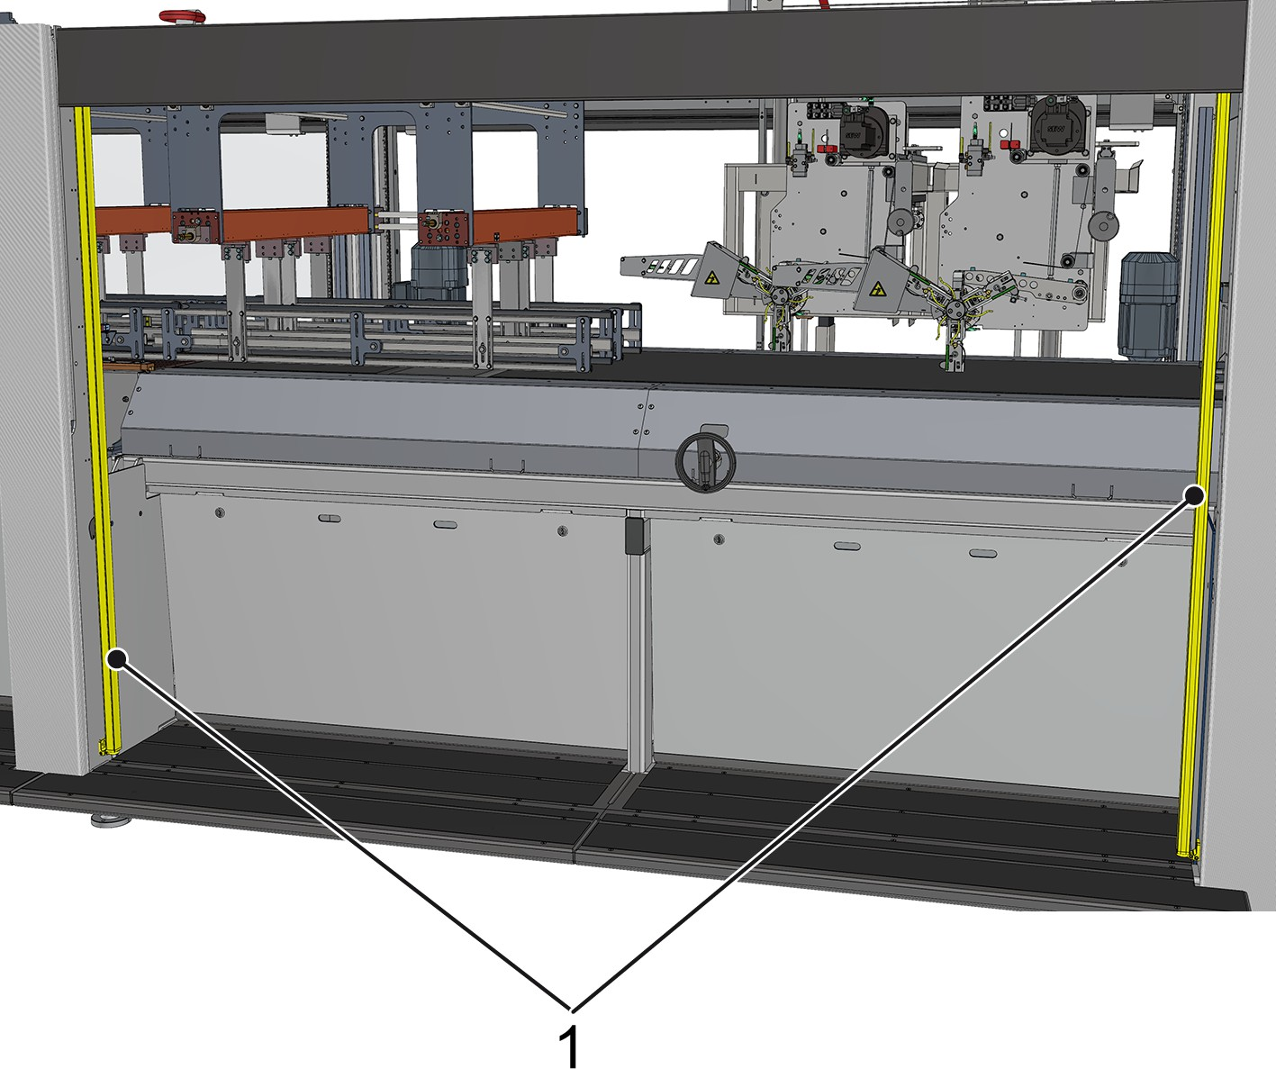

Figure 160: Safety light curtain
1 Transmitter and receiver for the safety light curtain
The safety light curtain is located on the operator side in the "Carrying handles" process module.
The transmitter for the safety light curtain transmits invisible infrared light, which is detected by the receiver.
If the light beam from the safety light curtain is broken while the machine is running, the "Carrying handles" process module stops. The [Start] button on the operating console at the infeed of the "Car‐ rying handles" process module flashes quickly.

Activating the safety light curtain Personnel:  Operating personnel
Prerequisite:
- The cause of the broken light beam has been rectified.
- Press the [Delete fault] button.
- Start the machine.

    - Repair switch
A repair switch disconnects individual machine components from the power supply. It is possible to secure the repair switch against unau‐ thorised activation using a padlock.
The repair switch has the following settings:
- 0: the components are isolated from the power supply.
- I: the components are supplied with electrical power. The repair switches are located at the following points:
- Metering belt, left in the "Product feed" process module
- Metering belt, right in the "Product feed" process module
- Feed belt, left in the "Product feed" process module
- Feed belt, right in the "Product feed" process module
- Separation belt in the "Separate" process module
- Height adjustment in the "Alignment" process module
- Height adjustment in the "Gluing" process module
- Master track in the "Turning" process module
- Turning track left in the "Turning" process module
- Turning track centre in the "Turning" process module
- Turning track right in the "Turning" process module
- Correction belt left in the "Turning" process module
- Correction belt right in the "Turning" process module
- Correction belt centre left in the "Turning" process module
- Correction belt centre right in the "Turning" process module
- Correction belt right left in the "Turning" process module
- Correction belt right right in the "Turning" process module
- Buffer belt in the "Buffering" process module
- Roller transfer in the "Buffering" process module
- Drive for dispenser A line 1 in the "Carrying handles" process module
- Drive for dispenser B line 1 in the "Carrying handles" process module
- Drive for dispenser A line 2 in the "Carrying handles" process module
- Drive for dispenser B line 2 in the "Carrying handles" process module
- Drive for dispenser A line 3 in the "Carrying handles" process module
- Drive for dispenser B line 3 in the "Carrying handles" process module
- Conveyor system

  - Signalling equipment
    - Signal lamps
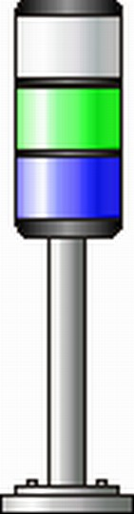

Figure 161: Signal lamp
The machine is equipped with two signal lamps. The lamps in the signal lamp signal different machine operating modes.
The top lamp lights up in three colours: white, yellow and red.
The signal lamps are located above the operator consoles at the infeed of the "Separate" process module and the infeed of the "Car‐ rying handles" process module.

Lamp colour | Lamp status
Lamp colour | Permanently illuminated | Flashing
White | Machine production is under way | Automatic restart (standby)
Yellow | Insufficient material (machine production is under way) | Insufficient material (machine in standby mode)
Red | Emergency stop activated | Open safety device
Green | Power ON | Service ON
Blue | Fault present; operator interven‐ tion required | Fault ready to be acknowledged

    - Signal horns
The machine is equipped with two signal horns.
The signal horns indicate different machine operating modes via audible signals.
The signal horns are either integrated into the signal lamp or attached on the outside of the machine as an individual component.

Signal | Operating status
Continuous interval signal | Warning:  - Product backlog downstream of the machine
Short signal | The [Operation On/Off] key switch was set to  [On]. The status display lights up.

  - Operating controls
    - Overview
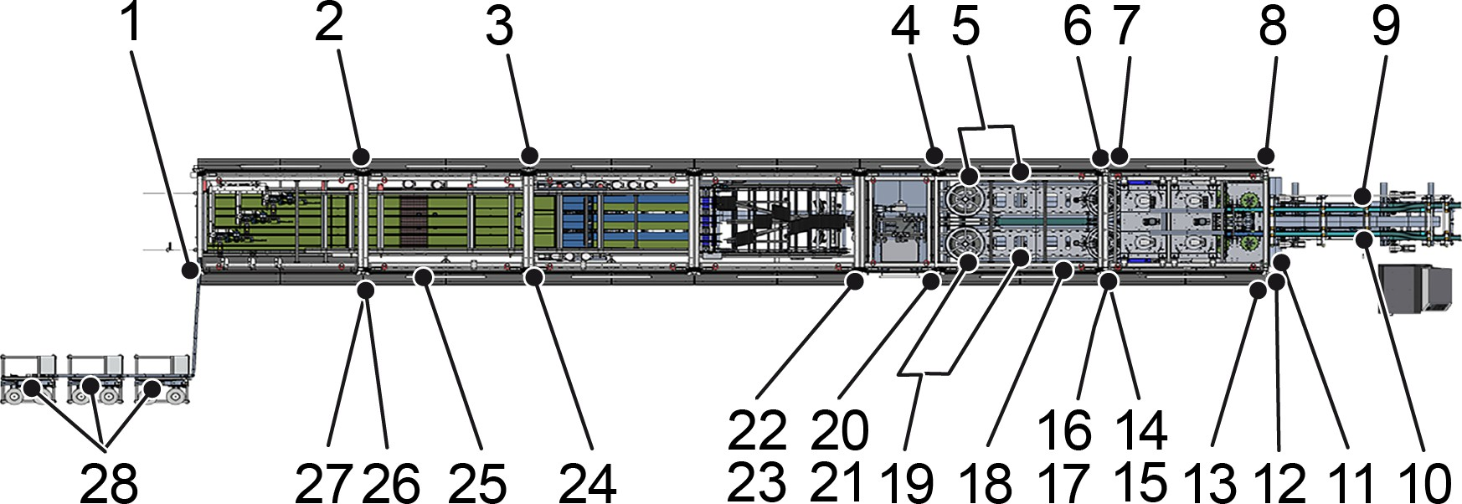

Figure 162: Machine
- Shut-off valve on the compressed air servicing unit at the machine outfeed
- "Buffering" operating controls (rear)
- "Turning" operating controls (rear)
- "Ejecting" operating controls (rear)
- "Changing station" operating controls (rear)
- "Gluing" operating controls (rear)
- "Rinsing" operating control (rear side)
- "Separate" operating controls (rear)
- "Feed belt" operating control (rear)
- "Feed belt" operating control (operator side)
- Shut-off valve on the compressed air servicing unit at the machine infeed
- [Power Packer ON-OFF] operating control at the infeed of the "Separate" process module
- Operator console at the infeed of the "Separate" process module
- "Rinsing" operating control (operator side)
- Height adjustment operating controls in the "Alignment" process module (operator side)
- "Gluing" operating controls (operator side)
- Height adjustment operating controls in the "Gluing" process module (operator side)
- Manual control unit on the front machine section
- "Changing station" operating controls (operator side)

- "Ejecting" operating controls (operator side)
- "Container" operating controls
- "Distributor adjustment" operating controls
- "Distributor lubrication" operating control
- "Turning" operating controls (operator side)
- Manual control unit on the rear machine section
- Operator console at the infeed of the "Carrying handles" process module
- [Power Packer ON-OFF] operating control at the infeed of the "Carrying handles" process module
- "Adhesive tape station" operating controls
The figure shows the approximate positions at which the operating controls are located.
The operating controls of the switch cabinets for the front and rear machine sections are located on the switch cabinets.
The switch cabinets are located next to the machine or in the desig‐ nated room.
The conveyor system operating controls are located on the conveyor system. The conveyor system is located upstream or downstream of the machine.

    - Shut-off valve on the compressed air maintenance unit at the machine outfeed
The position can be found in the overview.
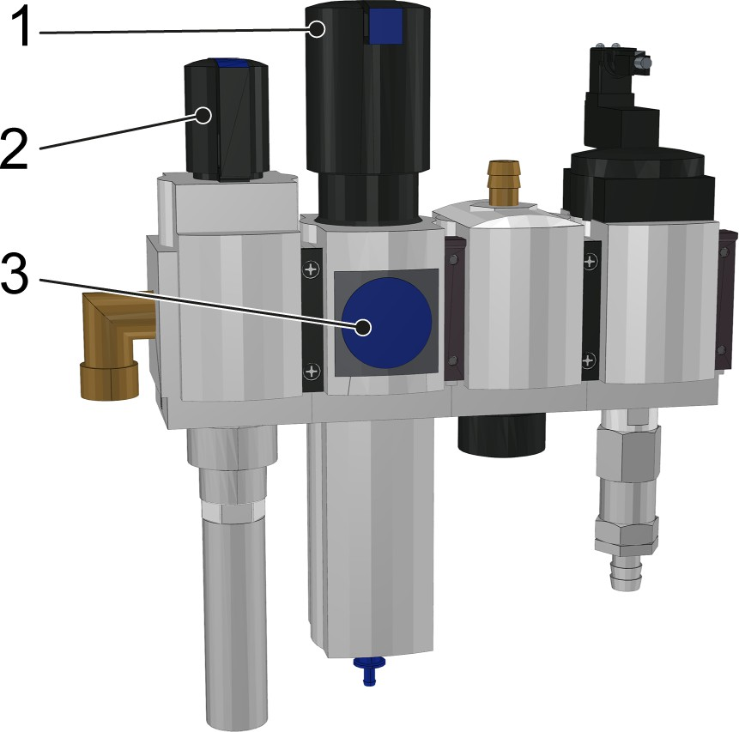

Figure 163: Compressed air maintenance unit (example)
- Pressure controller
- Shut-off valve
- Pressure gauge

The shut-off valve opens and closes the compressed air supply to the rear part of the machine.
Position of the shut-off valve
- Transverse to the flow direction: compressed air supply closed
- Longitudinal to the flow direction: compressed air supply open
The pressure can be adjusted in the rear part of the machine using the pressure controller and pressure gauge.

    - "Buffering" operating controls (rear side) The position can be found in the overview.

Operating control | Description
  [Start] | Starting the machine  - The button lights up:  The machine is switched on.  - The button is flashing:  The machine is ready to start. There are no more fault messages.  - The button does not light up:  The machine is not ready to start.  The machine can only be started if all error messages have been acknowledged and all moveable, detach‐ able safety equipment has been properly closed.  When the machine has been started, it performs the selected machine program.
  [Delete fault] | Acknowledging fault messages  - The button lights up:  A machine fault has occurred. A fault message appears on the touchscreen.  - The button is flashing:  A machine fault occurred and was rectified. The fault message can be acknowledged by pressing this button.  - The button does not light up: Operation is free of faults.  After correcting the fault, press the [Delete fault] button. Fault messages can only be acknowledged if the cause of the fault has been rectified.

Operating control | Description
  [Stop] | Stopping the machine  - Pressing the button:  The machine slows down and the machine stops at a defined position.
  [Lock doors] | Locking and unlocking the safety doors  - The button lights up:  The machine is ready to start. The safety doors are locked.  - The button is flashing:  The safety doors can be locked.  - The button does not light up:  The safety doors are not locked. The machine is not ready to start. The safety doors cannot be locked.

    - "Turning" operating controls (rear side) The position can be found in the overview.

Operating control | Description
[Start] | Starting the machine  - The button lights up:  The machine is switched on.  - The button is flashing:  The machine is ready to start. There are no more fault messages.  - The button does not light up:  The machine is not ready to start.  The machine can only be started if all error messages have been acknowledged and all moveable, detach‐ able safety equipment has been properly closed.  When the machine has been started, it performs the selected machine program.

Operating control | Description
[Delete fault] | Acknowledging fault messages  - The button lights up:  A machine fault has occurred. A fault message appears on the touchscreen.  - The button is flashing:  A machine fault occurred and was rectified. The fault message can be acknowledged by pressing this button.  - The button does not light up: Operation is free of faults.  After correcting the fault, press the [Delete fault] button. Fault messages can only be acknowledged if the cause of the fault has been rectified.
  [Stop] | Stopping the machine  - Pressing the button:  The machine slows down and the machine stops at a defined position.
[Lock doors] | Locking and unlocking the safety doors  - The button lights up:  The machine is ready to start. The safety doors are locked.  - The button is flashing:  The safety doors can be locked.  - The button does not light up:  The safety doors are not locked. The machine is not ready to start. The safety doors cannot be locked.

    - "Ejecting" operating controls (rear side) The position can be found in the overview.

Operating control | Description
[Start] | Starting the machine  - The button lights up:  The machine is switched on.  - The button is flashing:  The machine is ready to start. There are no more fault messages.  - The button does not light up:  The machine is not ready to start.  The machine can only be started if all error messages have been acknowledged and all moveable, detach‐ able safety equipment has been properly closed.  When the machine has been started, it performs the selected machine program.
[Delete fault] | Acknowledging fault messages  - The button lights up:  A machine fault has occurred. A fault message appears on the touchscreen.  - The button is flashing:  A machine fault occurred and was rectified. The fault message can be acknowledged by pressing this button.  - The button does not light up: Operation is free of faults.  After correcting the fault, press the [Delete fault] button. Fault messages can only be acknowledged if the cause of the fault has been rectified.
[Stop] | Stopping the machine  - Pressing the button:  The machine slows down and the machine stops at a defined position.
[Lock doors] | Locking and unlocking the safety doors  - The button lights up:  The machine is ready to start. The safety doors are locked.  - The button is flashing:  The safety doors can be locked.  - The button does not light up:  The safety doors are not locked. The machine is not ready to start. The safety doors cannot be locked.

    - "Change station" operating controls (rear side) The position can be found in the overview.

Operating control | Description
  [Jog change position] | - Press and hold the button:  Prerequisite for moving to the next change position with the [Change station enabling switch].
Operating control | Description
[Delete fault] | Acknowledging fault messages  - The button lights up:  A machine fault has occurred. A fault message appears on the touchscreen.  - The button is flashing:  A machine fault occurred and was rectified. The fault message can be acknowledged by pressing this button.  - The button does not light up: Operation is free of faults.  After correcting the fault, press the [Delete fault] button. Fault messages can only be acknowledged if the cause of the fault has been rectified.
  [Emergency stop switch] | Requirement:  - A hazardous situation has occurred.  - Press the switch:  The machine drive stops immediately.  The touchscreen displays the "Emergency stop switch actuated" fault message.  The corresponding lights on the signal lamps light up.
[Change position reached] | - The indicator lamp illuminates:  The change position has been reached.

Operating control | Description
[Change station ena‐ bling switch] | - Pressing the button:  Confirmation that the next change position is to be reached.  The format sets travel a defined distance to the next change position at a reduced speed.  Prerequisites:  - The setup mode is selected  - The [Jog change position] button is pressed and held and the [Change station enabling switch] is simultaneously pressed within 500 ms

    - "Gluing" operating controls (rear side) The position can be found in the overview.

Operating control | Description
[Start] | Starting the machine  - The button lights up:  The machine is switched on.  - The button is flashing:  The machine is ready to start. There are no more fault messages.  - The button does not light up:  The machine is not ready to start.  The machine can only be started if all error messages have been acknowledged and all moveable, detach‐ able safety equipment has been properly closed.  When the machine has been started, it performs the selected machine program.

Operating control | Description
[Delete fault] | Acknowledging fault messages  - The button lights up:  A machine fault has occurred. A fault message appears on the touchscreen.  - The button is flashing:  A machine fault occurred and was rectified. The fault message can be acknowledged by pressing this button.  - The button does not light up: Operation is free of faults.  After correcting the fault, press the [Delete fault] button. Fault messages can only be acknowledged if the cause of the fault has been rectified.
[Stop] | Stopping the machine  - Pressing the button:  The machine slows down and the machine stops at a defined position.
[Lock doors] | Locking and unlocking the safety doors  - The button lights up:  The machine is ready to start. The safety doors are locked.  - The button is flashing:  The safety doors can be locked.  - The button does not light up:  The safety doors are not locked. The machine is not ready to start. The safety doors cannot be locked.

    - "Rinsing" operating controls (rear side) See the overview for the position.

Operating control | Description
  [Start rinsing] | Starting the rinsing process  - Pressing the button:  The rinsing process starts.

Operating control | Description
  [Rinse top/ bottom] | Selecting the rinsing process  - Switch to [top]:  The rinsing process for the upper hot-melt glue application head is selected.  - Switch to [bottom]:  The rinsing process for the lower hot-melt glue application head is selected.
  [Rinsing active] | - The indicator lamp is illuminated: The rinsing process is active.  - The indicator lamp flashes:  The rinsing process can be started. There are no more fault messages.  - The indicator lamp is not illuminated.  The rinsing process cannot be started. The machine is not ready to start.

    - "Separate" operating controls (rear) See the overview for the position.

Operating control | Description
[Start] | Starting the machine  - The button lights up:  The machine is switched on.  - The button flashes:  The machine is ready to start. There are no more fault messages.  - The button does not light up:  The machine is not ready to start.  The machine can only be started once all error mes‐ sages have been acknowledged and all moveable iso‐ lating safety equipment has been closed correctly.  When the machine has been started, it performs the selected machine program.

Operating control | Description
[Delete fault] | Acknowledging fault messages  - The button lights up:  A machine fault has occurred. A fault message appears on the touchscreen.  - The button flashes:  A machine fault occurred and has now been resolved. The error message can be acknowl‐ edged with this button.  - The button does not light up:  The machine is operating without any faults.  After correcting the fault, press the [Delete fault] button. Fault messages can only be acknowledged if the cause of the fault has been rectified.
[Stop] | Stopping the machine  - Pressing the button:  The machine slows down and the machine stops at a defined position.
[Locking doors] | Locking and unlocking safety doors  - The button lights up:  The machine is ready to start. The safety doors are locked.  - The button flashes:  The safety doors can be locked.  - The button does not light up:  The safety doors are not locked. The machine is not ready to start. The safety doors cannot be locked.

    - "Feed conveyor" operating control (rear side) The position can be found in the overview.

Operating control | Description
[Enable feed con‐ veyor/ collating system] | - Switch to [Feed conveyor] and hold until feed band starts.  - Switch to [Collating system]:  The feed conveyor and collating star start after an instance of insufficient products or after a product has fallen over on the feed conveyor.

    - "Feed conveyor" operating control (operator side) The position can be found in the overview.

Operating control | Description
[Enable feed con‐ veyor/ collating system] | - Switch to [Feed conveyor] and hold until feed band starts.  - Switch to [Collating system]:  The feed conveyor and collating star start after an instance of insufficient products or after a product has fallen over on the feed conveyor.

    - Shut-off valve on the compressed air maintenance unit at the machine infeed
The position can be found in the overview.

Figure 164: Compressed air maintenance unit (example)
- Pressure controller
- Shut-off valve
- Pressure gauge

The shut-off valve opens and closes the compressed air supply to the front part of the machine.
Position of the shut-off valve
- Transverse to the flow direction: compressed air supply closed
- Longitudinal to the flow direction: compressed air supply open
The pressure can be adjusted in the front part of the machine using the pressure controller and pressure gauge.

    - [Power Packer ON-OFF] operating control at the infeed of the "Separate" process module
See the overview for the position.

Operating control | Description
[Power Packer ON- OFF] | Switching the machine output on and off:  - Turn the [Power Packer ON-OFF] selector switch to the [ON] position.  The assigned process modules can be switched on and operated.  - Turn the [Power Packer ON-OFF] selector switch to the [OFF] position.  The power supply to the assigned process mod‐ ules is switched off and the drives cannot be switched on. The switch cabinet is not discon‐ nected from the power supply.  Note for machines with special or additional devices: It is possible that special or additional devices are not disconnected from the power supply.

    - "Gluing" operating controls (operator side) See the overview for the position.

Operating control | Description
[Start rinsing] | Starting the rinsing process  - Pressing the button:  The rinsing process starts.
  [Rinse top/ bottom] | Selecting the rinsing process  - Switch to [top]:  The rinsing process for the upper hot-melt glue application head is selected.  - Switch to [bottom]:  The rinsing process for the lower hot-melt glue application head is selected.

Operating control | Description
[Rinsing active] | - The indicator lamp is illuminated: The rinsing process is active.  - The indicator lamp flashes:  The rinsing process can be started. There are no more fault messages.  - The indicator lamp is not illuminated.  The rinsing process cannot be started. The machine is not ready to start.

    - Height adjustment operating controls in the "Alignment" process module (operator side)
See the overview for the position.

Operating control | Description
[Upward height adjustment for align‐ ment] | Raising the pressing units in the "Alignment" process module  - This indicator lamp and the [Downward height adjustment for alignment] indicator lamp light up: The target position of the pressing units has been  reached.  - This indicator lamp flashes and the [Downward height adjustment for alignment] indicator lamp does not light up:  The pressing units must be raised using the [Raise/lower height adjustment for alignment] selector switch.
[Downward height adjustment for align‐ ment] | Lowering the pressing units in the "Alignment" process module  - This indicator lamp and the [Upward height adjust‐ ment for alignment] indicator lamp light up:  The target position of the pressing units has been reached.  - This indicator lamp flashes and the [Upward height adjustment for alignment] indicator lamp does not light up:  The pressing units must be lowered using the [Raise/lower height adjustment for alignment] selector switch.

Operating control | Description
[Raise/ lower height adjustment for align‐ ment] | - Switch to [Raise]:  The pressing units are raised.  - Switch to [Lower]:  The pressing units are lowered.

    - "Gluing" operating controls (operator side) The position can be found in the overview.

Operating control | Description
[Start] | Starting the machine  - The button lights up:  The machine is switched on.  - The button is flashing:  The machine is ready to start. There are no more fault messages.  - The button does not light up:  The machine is not ready to start.  The machine can only be started if all error messages have been acknowledged and all moveable, detach‐ able safety equipment has been properly closed.  When the machine has been started, it performs the selected machine program.
[Delete fault] | Acknowledging fault messages  - The button lights up:  A machine fault has occurred. A fault message appears on the touchscreen.  - The button is flashing:  A machine fault occurred and was rectified. The fault message can be acknowledged by pressing this button.  - The button does not light up: Operation is free of faults.  After correcting the fault, press the [Delete fault] button. Fault messages can only be acknowledged if the cause of the fault has been rectified.

Operating control | Description
[Stop] | Stopping the machine  - Pressing the button:  No more products are run into the "Gluing" process module. The products within the "Gluing" process module are transported to the down‐ stream process module.  The machine slows down and the machine stops at a defined position.
[Lock doors] | Locking and unlocking the safety doors  - The button lights up:  The machine is ready to start. The safety doors are locked.  - The button is flashing:  The safety doors can be locked.  - The button does not light up:  The safety doors are not locked. The machine is not ready to start. The safety doors cannot be locked.

    - Height adjustment operating controls in the "Gluing" process module (operator side)
See the overview for the position.

Operating control | Description
[Upward height adjustment for gluing] | Raising the pressing units in the "Gluing" process module  - This indicator lamp and the [Downward height adjustment for gluing] indicator lamp light up:  The target position of the pressing units has been reached.  - This indicator lamp flashes and the [Downward height adjustment for gluing] indicator lamp does not light up:  The pressing units must be raised using the [Raise/lower height adjustment for gluing] selector switch.

Operating control | Description
[Downward height adjustment for gluing] | Lowering the pressing units in the "Gluing" process module  - This indicator lamp and the [Upward height adjust‐ ment for gluing] indicator lamp light up:  The target position of the pressing units has been reached.  - This indicator lamp flashes and the [Upward height adjustment for gluing] indicator lamp does not light up:  The pressing units must be lowered using the [Raise/lower height adjustment for gluing] selector switch.
  [Raise/ lower height adjustment for gluing] | - Switch to [Raise]:  The pressing units are raised.  - Switch to [Lower]:  The pressing units are lowered.

    - Manual control unit on the front machine section
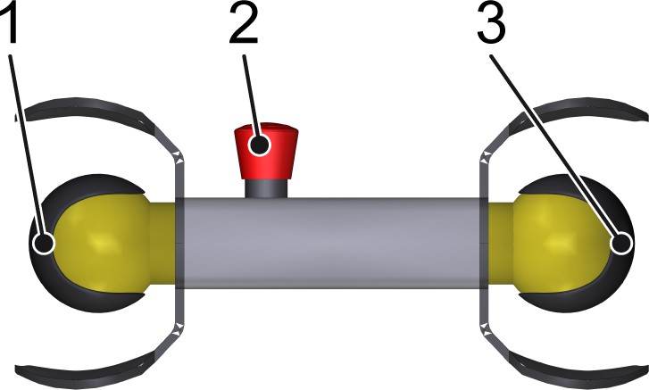

Figure 165: Manual control unit
- [OK] button
- Emergency stop switch
- [Jog] button
The manual control unit allows the front machine section to run in jog mode and to start or stop at any position. In jog mode, the front machine section moves at jog speed.
Moving the front machine section in jog mode Personnel:  Operating personnel
- Switching on jog mode
See chapter ‘Operation’, section ‘Production’ > ‘Jog mode’.

- Simultaneously press and hold the [OK] and [Jog] buttons on the manual control unit.
  - The machine runs at jog speed.
- Release the [OK] or [Jog] button.
  - The machine stops as soon as one of the buttons is released.

    - "Changing station" operating controls (operator side) The position can be found in the overview.

Operating control | Description
[Jog change position] | - Press and hold the button:  Prerequisite for moving to the next change position with the [Change station enabling switch].
Operating control | Description
[Delete fault] | Acknowledging fault messages  - The button lights up:  A machine fault has occurred. A fault message appears on the touchscreen.  - The button is flashing:  A machine fault occurred and was rectified. The fault message can be acknowledged by pressing this button.  - The button does not light up: Operation is free of faults.  After correcting the fault, press the [Delete fault] button. Fault messages can only be acknowledged if the cause of the fault has been rectified.

Operating control | Description
[Emergency stop switch] | Requirement:  - A hazardous situation has occurred.  - Press the switch:  The machine drive stops immediately.  The touchscreen displays the "Emergency stop switch actuated" fault message.  The corresponding lights on the signal lamps light up.
[Change position reached] | - The indicator lamp illuminates:  The change position has been reached.
[Change station ena‐ bling switch] | - Pressing the button:  Confirmation that the next change position is to be reached.  The format sets travel a defined distance to the next change position at a reduced speed.  Prerequisites:  - The setup mode is selected  - The [Jog change position] button is pressed and held and the [Change station enabling switch] is simultaneously pressed within 500 ms

    - "Ejecting" operating controls (operator side) The position can be found in the overview.

Operating control | Description
[Start] | Starting the machine  - The button lights up:  The machine is switched on.  - The button is flashing:  The machine is ready to start. There are no more fault messages.  - The button does not light up:  The machine is not ready to start.  The machine can only be started if all error messages have been acknowledged and all moveable, detach‐ able safety equipment has been properly closed.  When the machine has been started, it performs the selected machine program.
[Delete fault] | Acknowledging fault messages  - The button lights up:  A machine fault has occurred. A fault message appears on the touchscreen.  - The button is flashing:  A machine fault occurred and was rectified. The fault message can be acknowledged by pressing this button.  - The button does not light up: Operation is free of faults.  After correcting the fault, press the [Delete fault] button. Fault messages can only be acknowledged if the cause of the fault has been rectified.
[Stop] | Stopping the machine  - Pressing the button:  The machine slows down and the machine stops at a defined position.
[Lock doors] | Locking and unlocking the safety doors  - The button lights up:  The machine is ready to start. The safety doors are locked.  - The button is flashing:  The safety doors can be locked.  - The button does not light up:  The safety doors are not locked. The machine is not ready to start. The safety doors cannot be locked.

    - "Container" operating controls See the overview for the position.

Operating control | Description
[Container change] | Indicator lamp for displaying the container change status  - The button lights up:  The container is not currently in the machine. The safety door is open.  - The button does not light up:  The container is located in the machine. The safety door is locked.
[Remove container safety door] | Button for locking and unlocking the safety door on the container  - The button flashes:  The container can be changed. Confirming with this button unlocks the safety door.  - The button does not light up:  The container cannot be changed. The safety door remains locked.  After changing the container, press the [Remove con‐ tainer safety door] button to lock the safety door again.

    - "Distributor adjustment" operating controls See the overview for the position.

Operating con‐ trols | Description
  [Adjustment com‐ plete] | Indicator lamp to display the adjustment status  - The indicator lamp is illuminated:  The adjustment sequence is complete.  - The indicator lamp goes out: Production is starting.
  [Start adjustment] | Starting the adjustment  - Pressing the button:  The selected adjustment sequence is exe‐ cuted.

    - "Distributor lubrication" operating control See the overview for the position.

Operating con‐ trols | Description
[Manual lubrica‐ tion] | Starting manual lubrication of the distributor  - Pressing the button:  Manual lubrication of the distributor starts.

    - "Turning" operating controls (operator side) The position can be found in the overview.

Operating control | Description
[Start] | Starting the machine  - The button lights up:  The machine is switched on.  - The button is flashing:  The machine is ready to start. There are no more fault messages.  - The button does not light up:  The machine is not ready to start.  The machine can only be started if all error messages have been acknowledged and all moveable, detach‐ able safety equipment has been properly closed.  When the machine has been started, it performs the selected machine program.

Operating control | Description
[Delete fault] | Acknowledging fault messages  - The button lights up:  A machine fault has occurred. A fault message appears on the touchscreen.  - The button is flashing:  A machine fault occurred and was rectified. The fault message can be acknowledged by pressing this button.  - The button does not light up: Operation is free of faults.  After correcting the fault, press the [Delete fault] button. Fault messages can only be acknowledged if the cause of the fault has been rectified.
[Stop] | Stopping the machine  - Pressing the button:  The machine slows down and the machine stops at a defined position.
[Lock doors] | Locking and unlocking the safety doors  - The button lights up:  The machine is ready to start. The safety doors are locked.  - The button is flashing:  The safety doors can be locked.  - The button does not light up:  The safety doors are not locked. The machine is not ready to start. The safety doors cannot be locked.

    - Manual control unit on the rear machine section

Figure 166: Manual control unit
- [OK] button
- Emergency stop switch
- [Jog] button
The manual control unit allows the rear machine section to run in jog mode and to start or stop at any position. In jog mode, the rear machine section moves at jog speed.
Moving the rear machine section in jog mode Personnel:  Operating personnel
- Switching on jog mode
See chapter ‘Operation’, section ‘Production’ > ‘Jog mode’.
- Simultaneously press and hold the [OK] and [Jog] buttons on the manual control unit.
  - The machine runs at jog speed.
- Release the [OK] or [Jog] button.
  - The machine stops as soon as one of the buttons is released.

    - [Power Packer ON-OFF] operating control at the infeed of the "Carrying handles" process module
See the overview for the position.

Operating control | Description
[Power Packer ON- OFF] | Switching the machine output on and off:  - Turn the [Power Packer ON-OFF] selector switch to the [ON] position.  The assigned process modules can be switched on and operated.  - Turn the [Power Packer ON-OFF] selector switch to the [OFF] position.  The power supply to the assigned process mod‐ ules is switched off and the drives cannot be switched on. The switch cabinet is not discon‐ nected from the power supply.  Note for machines with special or additional devices: It is possible that special or additional devices are not disconnected from the power supply.

    - "Adhesive tape station" operating elements The position can be found in the overview.

Operating control | Description
[Start spool A] | - The button lights up: Spool A is switched on.  - The button is flashing: Spool A is ready to start.  - The button does not light up: Spool A is not ready to start.
[Start spool B] | - The button lights up: Spool B is switched on.  - The button is flashing: Spool B is ready to start.  - The button does not light up: Spool B is not ready to start.

Operating control | Description
[Emergency stop switch] | Requirement:  - A hazardous situation has occurred.  - Press the switch:  The drives of the adhesive tape station stop imme‐ diately.  The touchscreen displays the "Emergency stop switch actuated" fault message.  The corresponding lights on the signal lamps light up.

    - "Switch cabinet" operating control for the front machine section
The "Switch cabinet" operating control is located on the switch cab‐ inet for the front machine section.

Operating controls | Description
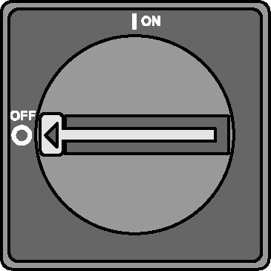  [Main switch] | Switching the power supply on and off for the assigned process modules:  - Switch to [ON-I] position: switched on  - Switch to [OFF-O] position: switched off  The assigned process modules are fully disconnected from the power supply.

    - "Switch cabinet" operating control for the rear machine section
The "Switch cabinet" operating control is located on the switch cab‐ inet for the rear machine section.

Operating controls | Description
[Main switch] | Switching the power supply on and off for the assigned process modules:  - Switch to [ON-I] position: switched on  - Switch to [OFF-O] position: switched off  The assigned process modules are fully disconnected from the power supply.

    - Operating controls for "Conveyor system"
      - "Outfeed control TG017" operating controls
The "Outfeed control TG017" operating controls are located on the conveyor system at the machine infeed. These controls can be used to clear errors that affect the conveyor system and to start the con‐ veyor system. After the conveyor system is started, the machine starts up again.

Operating con‐ trols | Description
  [Outfeed control start] | Starts the conveyor system and the machine after a fault message has been acknowledged in the conveyor system area  - The button lights up:  Conveyor system and machine are switched on.  - Button flashes:  Conveyor system and machine are ready to start and no further fault messages are pending.  - Button does not light up:  Conveyor system and machine are not ready to start.  The conveyor system and machine can only be started when all fault messages have been acknowledged and all movable guards have been closed properly.  When the conveyor system and machine have been started, run the selected machine pro‐ gram.

Operating con‐ trols | Description
[Outfeed control, fault reset] | Acknowledges error messages affecting the conveyor system  - The button lights up:  There is a fault in the conveyor system area. A fault message appears on the operator terminal.  - Button does not light up:  Conveyor system is operating without any faults.  After resolving the fault, press the [Control dis‐ charge, fault reset] button.

      - "Outfeed control TG019" operating controls
The "Outfeed control TG019" operating controls are located on the conveyor system at the machine infeed. These controls can be used to clear errors that affect the conveyor system and to start the con‐ veyor system. After the conveyor system is started, the machine starts up again.

Operating con‐ trols | Description
[Outfeed control start] | Starts the conveyor system and the machine after a fault message has been acknowledged in the conveyor system area  - The button lights up:  Conveyor system and machine are switched on.  - Button flashes:  Conveyor system and machine are ready to start and no further fault messages are pending.  - Button does not light up:  Conveyor system and machine are not ready to start.  The conveyor system and machine can only be started when all fault messages have been acknowledged and all movable guards have been closed properly.  When the conveyor system and machine have been started, run the selected machine pro‐ gram.

Operating con‐ trols | Description
[Outfeed control, fault reset] | Acknowledges error messages affecting the conveyor system  - The button lights up:  There is a fault in the conveyor system area. A fault message appears on the operator terminal.  - Button does not light up:  Conveyor system is operating without any faults.  After resolving the fault, press the [Control dis‐ charge, fault reset] button.

  - Preparing for operation

ENVIRONMENT!
Pre-melting unit
Switching on the pre-melting unit ahead of time increases energy consumption.
– Do not switch on the pre-melting unit earlier than 90 minutes before start of production.
ENVIRONMENT!
Hot-melt glue units
Switching on the hot-melt glue units prematurely increases energy consumption.
– Do not switch on the hot-melt glue units more than 90 minutes before the start of production.

Switching on the machine
Personnel:  Operating personnel
- Switch on both main switches.
- Set both [Power Packer ON-OFF] selector switches to [OFF].
- Set both [Operating mode] key switches to [Automatic].
- Set both [Operation on/off] key switches to the [On] position.
  - Both status displays light up.

Checking the type settings

Check the type setting for the type to be fed.
See the ‘Setup’ chapter.

    - Switching on the compressed air Switch on compressed air

Figure 167: Compressed air maintenance unit (example)
- Pressure controller
- Shut-off valve
- Pressure gauge
Personnel:  Operating personnel Requirement:
- The operator feeds compressed air of suitable quality into the supply line to the compressed air maintenance units under the appropriate operating pressure.
- Open the shut-off valves on the two compressed air mainte‐ nance units.
- Determine the necessary operating pressure for the machine.
The value is indicated on the labels on the compressed air main‐ tenance units.
- Check whether the necessary operating pressure is indicated on the pressure gages.
- Turn the pressure controllers to the right or left if necessary.
  - The pressure gages indicate the necessary operating pres‐ sure.

    - Filling the tank of the pre-melting unit
CAUTION!
Hot glue
Heating the hot glue produces vapour which can lead to irritation if inhaled for prolonged periods.
This may result in slight or minor injury.
- Avoid inhaling the vapour for long periods.
- Only open the pre-melting unit tank to refill it and close it again immediately.
- Keep the tanks of the hot glue devices closed.
WARNING!
Risk of burns at the pre-melting unit
Risk of burns on the surfaces of hot glue hoses.
Risk of burns due to hot glue in the tank of the pre- melting unit.
This could result in death or serious injury.
- Do not touch hot surfaces.
- Wear safety goggles and protective gloves when working on the pre-melting unit.

The pre-melting unit is located near the machine. The unit supplies hot glue to the hot glue devices.
For more information about operating the pre-melting unit, please refer to the purchased parts documentation.
Personnel:  Operating personnel
Prerequisites:
- The message "Minimum hot glue in pre-melting unit" appears on the operator console.
- The pre-melting unit signals a low filling level.
- The hot-melt blocks are clean and free of foreign objects.
- Open the tank flap.
- Carefully add the hot-melt blocks to the tank in small quantities.
- Fill the tank to maximum 30 mm below the opening of the tank.
- Close the tank flap.

    - Heating up the pre-melting unit
ENVIRONMENT!
Pre-melting unit
Switching on the pre-melting unit ahead of time increases energy consumption.
– Do not switch on the pre-melting unit earlier than 90 minutes before start of production.
Personnel:  Operating personnel Prerequisites:
- The pre-melting unit, hot-melt glue units and NatureMultiPacker are ready for operation.
- Switch the on/off switch on the pre-melting unit to the "On" posi‐ tion if it is switched off.
  - The target and actual temperature values are shown on the digital displays.
The [tank heater] LED display lights up and the tank on the pre-melting unit heats up.
- Wait until the tank and all other system components have heated up.
  - Once the actual temperature value is 3°C below the target temperature value, the programmable delay time starts.
During the delay time, the ‘Standby function’ and ‘Temperature OK and pump in operation’ LED displays flash.
When the set delay time has expired and all components have reached the target temperature of –3°C, the ‘Standby function’ and ‘Temperature OK and pump in operation’ LED displays switch to a continuous light.
If one of the components has not reached the target temper‐ ature value of –3°C at the end of the delay time, the LED displays switch off.

    - Heating up the hot-melt glue units
ENVIRONMENT!
Hot-melt glue units
Switching on the hot-melt glue units prematurely increases energy consumption.
– Do not switch on the hot-melt glue units more than 90 minutes before the start of production.

Personnel:  Operating personnel Heat up the hot-melt glue units.
Refer to the purchased parts documentation.

    - Loading a label
So that the cameras in the "Alignment (M53)" process module can identify the alignment of labels, the correct label must be loaded.
If the label has not yet been saved, it must first be read in. See chapter ‘Setup’, section ‘Reading in a label’.
Personnel:  Operating personnel
- At the operator console of the "Separating" process module, open the ‘Service > Align container’ view.
- Press the  ‘Label type selection’ button.
  - A selection menu opens.
- Select and confirm the appropriate label.

    - Threading the adhesive tape
      - Adhesive tape route diagram
In the "Carrying handles" process module, the adhesive tape runs through the following stations:
        - Adhesive tape station
        - Adhesive tape feed
        - Application unit

      - Preparing the threading process for the adhesive tape
For production, the adhesive tape must be threaded according to the routing diagram.
Sequence of the stations:
        - Adhesive tape station
          - Adhesive tape connection unit
          - Adhesive tape store
        - Adhesive tape feed
        - Application unit
Diverter rollers with smooth and rough surfaces guide the adhesive tape.

The adhesive tape must be passed around the diverter rollers in such a way that the adhesive side only runs over the rough diverter rollers and the non-adhesive side only runs over the smooth diverter rollers.
Prerequisite: Both [Packer power On / Off] selector switches must be set to [On].
On the adhesive tape station, press the [Start dispenser A] or [Start dispenser B] button to select the corresponding adhesive tape spool.
- The selected button lights up.

      - Loading the adhesive tape station with adhesive tape spool and threading the adhesive tape
Each adhesive tape station must first be loaded with an adhesive tape spool. The adhesive tape of this adhesive tape spool is threaded through the adhesive tape station and then delivered to the applica‐ tion unit via the adhesive tape feed.
A second adhesive tape spool can then be prepared as a backup spool, so that the adhesive tapes are stuck together automatically as soon as the end of the active adhesive tape spool is detected by a sensor.

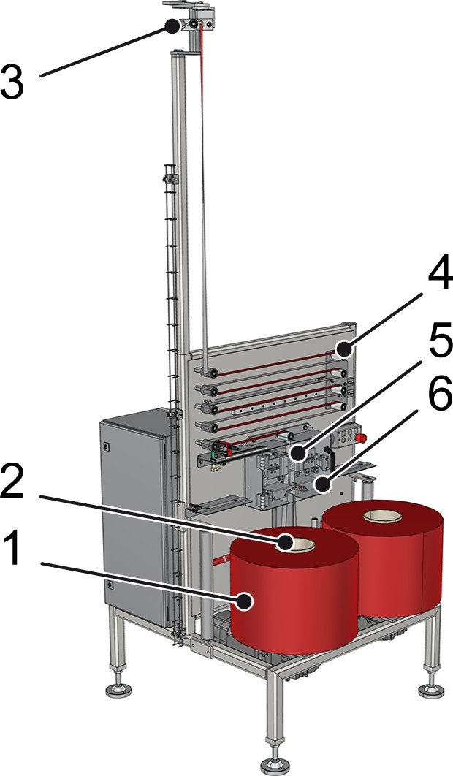

Figure 168: Adhesive tape station
- Adhesive tape spool
- Spool holder
- Adhesive tape feed
- Adhesive tape store
- Adhesive tape cutter
- Adhesive tape connection unit

CAUTION!
Heavy carrying handle spools
Loading the machine with carrying handle spools may require particular physical strain.
This could result in slight or minor injury.
– When loading the machine with carrying handle spools, avoid any physical strain.

WARNING!
Adhesive tape knife
The adhesive tape knife is very sharp. Risk of punc‐ tures, ruptures or cuts.
This could result in death or serious injury.
- Wear cut-resistant protective gloves.
- Observe warning information on the machine.
Personnel:  Operating personnel
- Place the adhesive tape spool on the selected spool holder.
- Thread the adhesive tape in accordance with the routing dia‐ gram. The routing diagram for the adhesive tape is displayed on the adhesive tape station.
Pass the non-adhesive side of the adhesive tape around the smooth diverter rollers and the adhesive side of the adhesive tape around the rough diverter rollers.
- In preparation for automatic replacement, place a second adhe‐ sive tape spool on the other spool holder as the backup spool.
- Pass the adhesive tape of the backup spool around the lower diverter rollers and into the adhesive tape connecting unit as illustrated in the routing diagram.
- Use the adhesive tape cutter to cut the adhesive tape of the spare spool approximately 1 cm below the transition from the handle surface to the adhesive surface.
  - The adhesive tape of the selected adhesive tape spool is connected to the adhesive tape of the backup spool auto‐ matically as soon as the end of the adhesive tape spool is detected by a sensor.

      - Adhesive tape feed
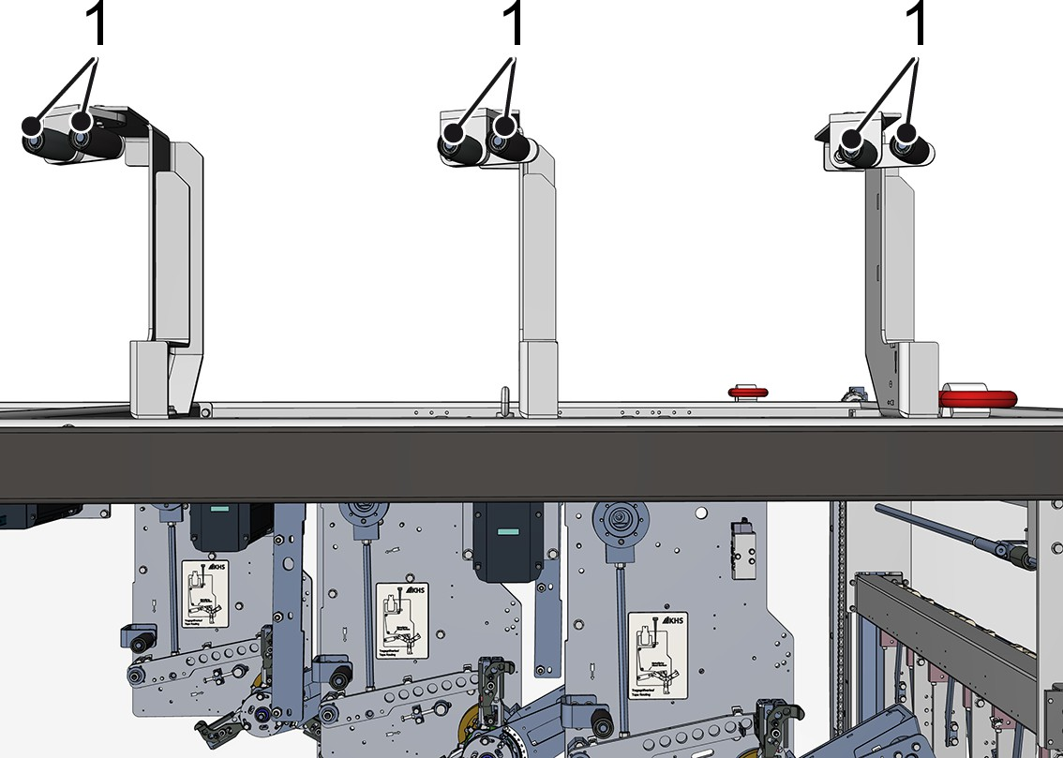

Figure 169: Adhesive tape feed (example)
1 Diverter rollers

Personnel:  Operating personnel
Guide the adhesive tape around the diverter rollers of the adhe‐ sive tape feed in accordance with the routing diagram.
The routing diagram for the adhesive tape is displayed on the adhesive tape feed and application unit.

      - Application unit
WARNING!
Adhesive tape knife
The adhesive tape knife is very sharp. Risk of punc‐ tures, ruptures or cuts.
This could result in death or serious injury.
- Wear cut-resistant protective gloves.
- Observe warning information on the machine.

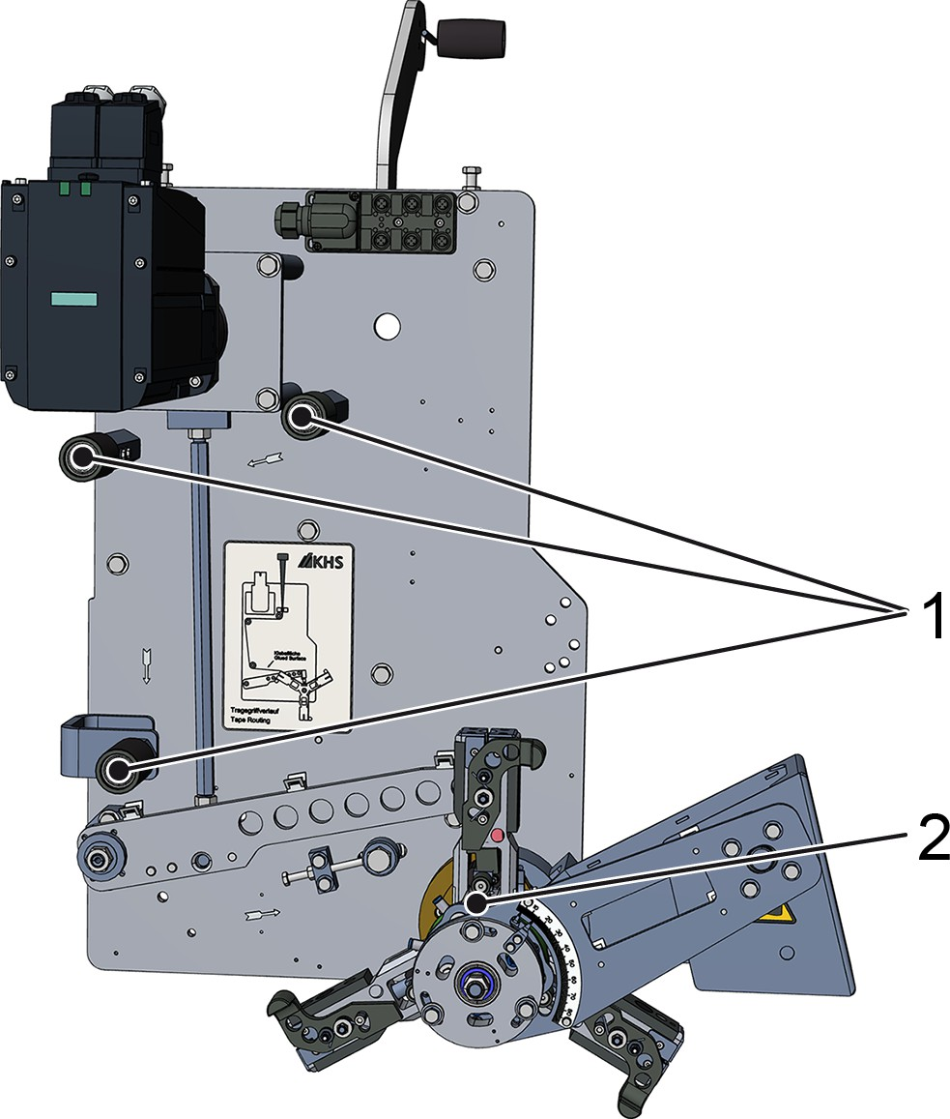

Figure 170: Application unit
- Diverter rollers
- Rotation star

Personnel:  Operating personnel
- Pass the adhesive tape around the diverter rollers in accordance with the routing diagram.
The routing diagram for the adhesive tape is displayed on the application unit.
- Thread the adhesive tape into the rotation star. Allow the end of the adhesive tape to protrude by approximately 1 cm.

  - Production
This chapter provides instructions for personnel on running produc‐ tion.

